**HAND EXERCISES TO IMPROVE INTRINSIC HAND STRENGTH**

 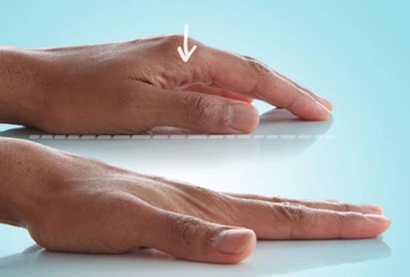

1. **Make a Fist (close & open) 2. Finger Stretch (up & down)**

 

**3. Claw Stretch 4. Arms to the Sky**

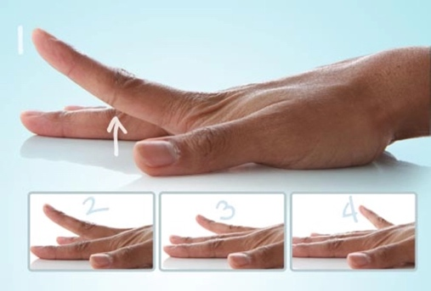 

**5. Finger Lifts 6. Thumb Extension/Flexion**

 

**7. Finger to Thumb 8. Prayer Stretch**